**4.1**

-- 4.1

SELECT

loc.location_name AS ‘Country Name(CN)’,

-- The following CASE statements are to convert NULL to 0 or the correct month.

CASE WHEN MV1.month IS NOT NULL THEN MV1.month ELSE '2022-04' END AS 'Observation Months 1 (OM1)',

CASE WHEN MV1.total_administered_vaccine IS NOT NULL THEN MV1.total_administered_vaccine ELSE 0 END AS 'Administered Vaccine on OM1 (VOM1)',

CASE WHEN MV2.month IS NOT NULL THEN MV2.month ELSE '2022-05' END AS 'Observation Months 2 (OM2)',

CASE WHEN MV2.total_administered_vaccine IS NOT NULL THEN MV2.total_administered_vaccine ELSE 0 END AS 'Administered Vaccine on OM2 (VOM2)',

CASE -- if any month value was 0, it means that the month’s data wasn’t collected. Turn 0 into ‘no valid data collected’.

WHEN (MV1.total_administered_vaccine IS NULL AND MV2.total_administered_vaccine IS NULL) OR

(MV1.total_administered_vaccine = 0 AND MV2.total_administered_vaccine = 0) THEN 'No valid data collected for the selected month'

WHEN MV1.total_administered_vaccine = 0 THEN 'No valid data collected for OM1'

WHEN MV2.total_administered_vaccine = 0 THEN 'No valid data collected for OM2'

ELSE (MV2.total_administered_vaccine - MV1.total_administered_vaccine)

END AS 'Difference of totals (VOM1-VOM2)'

FROM

Locations loc

LEFT JOIN -- Some locations did not have records at 2022-04, so using LEFT JOIN Locations relation to include these no-record locations

(SELECT -- Get the monthly total administrated vaccine of each iso_code on 2022-04

iso_code,

strftime('%Y-%m', date) AS month,

SUM(daily_vaccinations) AS total_administered_vaccine

FROM

Daily_Records

WHERE strftime('%Y-%m', date) = '2022-04'

GROUP BY

iso_code, month

) AS MV1

ON loc.iso_code = MV1.iso_code

LEFT JOIN

(SELECT -- Get the monthly total administrated vaccine of each iso_code on 2022-05

iso_code,

strftime('%Y-%m', date) AS month,

SUM(daily_vaccinations) AS total_administered_vaccine

FROM

Daily_Records

WHERE strftime('%Y-%m', date) = '2022-05'

GROUP BY

iso_code, month

) AS MV2

ON loc.iso_code = MV2.iso_code

ORDER BY loc.iso_code;

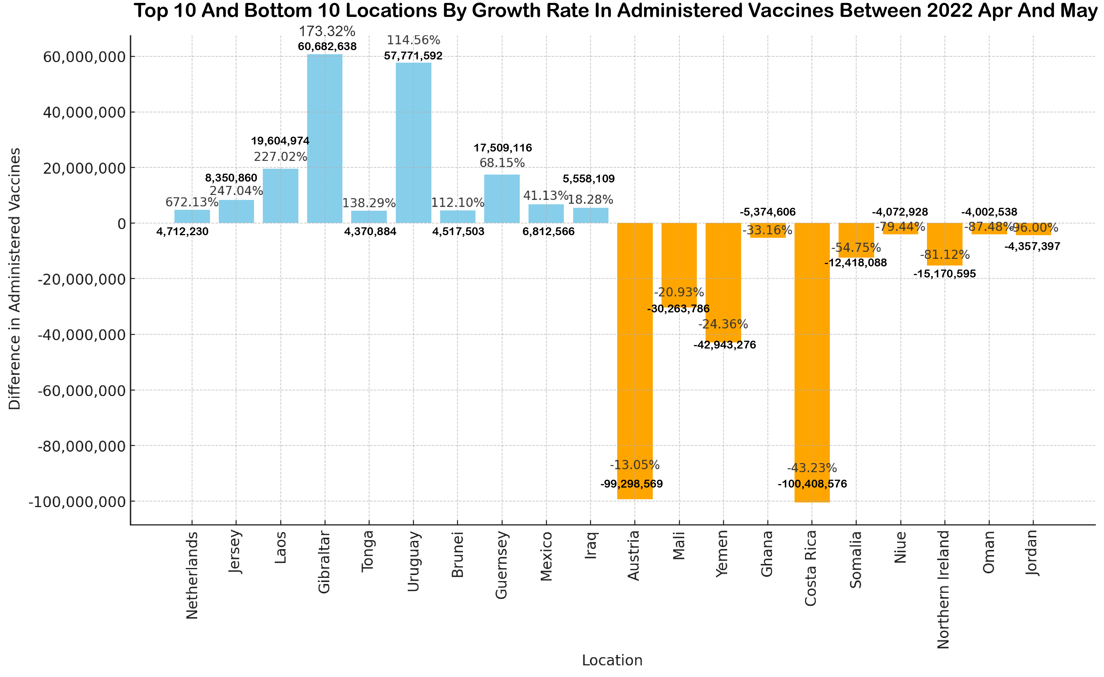

This bar chart presents the difference in administered vaccines between OM1(2022-04) and OM2(2022-05) for the top 10 and bottom 10 locations, ranked by their “growth rates”. The bars and numbers represent the numerical difference in vaccines administered, while the percentages above the bars indicate the growth rate for each location. The top 10 locations by growth rate are shown in sky blue, and the bottom 10 locations by growth rate are in orange. Through this visualization, we can observe which regions were actively promoting vaccination and which areas were gradually declining. For instance, the number of vaccinations in the Netherlands in May was almost 6.7 times that of the previous month, suggesting that they were actively promoting vaccination at that time.

**4.2**

-- 4.2

SELECT

loc.location_name AS 'Country Name',

mc.month AS 'Month',

mc.total_vaccinations AS 'Cumulative Doses'

FROM

(SELECT -- Calculate the total vaccinations for each country in each month

iso_code,

strftime('%Y-%m', date) AS month,

SUM(daily_vaccinations) AS total_vaccinations

FROM

Daily_Records

GROUP BY

iso_code,

strftime('%Y-%m', date)

) AS mc

JOIN

(SELECT -- Calculate the average total vaccinations for each month

month,

AVG(total_vaccinations) AS avg_vaccinations

FROM

(SELECT --Get sum of each month first, then calculate avg

iso_code,

strftime('%Y-%m', date) AS month,

SUM(daily_vaccinations) AS total_vaccinations

FROM

Daily_Records

GROUP BY

iso_code,

strftime('%Y-%m', date)

) AS Monthly_Cumulative

GROUP BY month

) AS ma

ON mc.month = ma.month

JOIN

Locations loc -- to get iso_code corresponding lecation_name

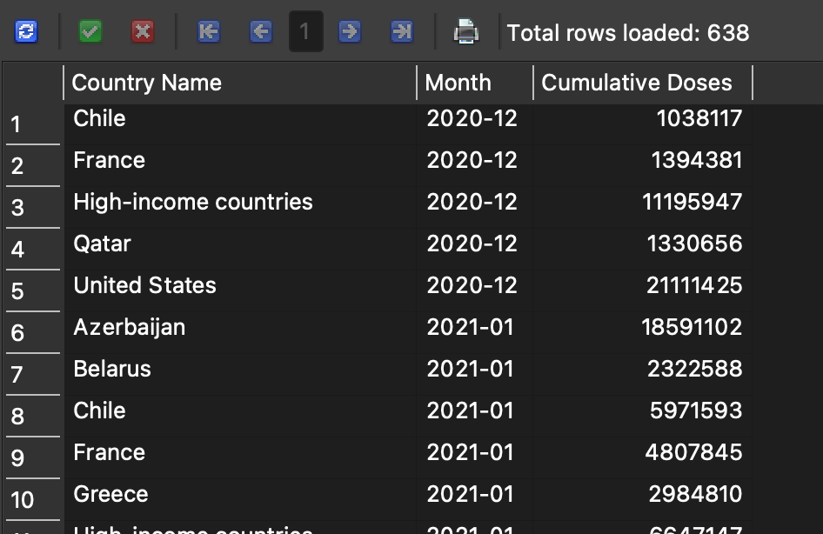ON mc.iso_code = loc.iso_code

WHERE

mc.total_vaccinations > ma.avg_vaccinations

ORDER BY

mc.month, loc.location_name;

This chart shows the number of times each region exceeded the average monthly doses administered between December 2020 and May 2024. Since the data is based on monthly cumulative doses, not the vaccination rate, countries with larger populations or special policies are likelier to have higher absolute numbers above the average. However, it is noteworthy that countries with large populations, such as the USA, India, or China, do not have many instances of exceeding the average. Instead, countries like Afghanistan (AFG), Uruguay (URY), and Costa Rica (CRI), which are not recognized as highly developed, show higher times exceeded the average administered vaccination doses.

**4.3**

-- 4.3

-- There are two ways to achieve this query, but the option’s information is more detailed.

-- Option1

SELECT

DISTINCT pv.Mname AS Vaccine_Type,

loc.location_name AS Country

FROM

Provides_Vaccines pv

JOIN Locations loc ON pv.iso_code = loc.iso_code -- Join ISO code to get the country name

ORDER BY loc.location_name; -- Order by country name;

--Option2

SELECT

DISTINCT s.Mname AS Vaccine_Type,

loc.location_name AS Country

FROM

Suppliers s

JOIN Locations loc ON s.iso_code = loc.iso_code

ORDER BY loc.location_name;

This chart shows which vaccine brands were used by most countries, giving us an idea of the distribution of vaccine supplier coverage. We can also identify those brands only used by a few countries, likely regional manufacturers or distributors.**一張含有 文字, 螢幕擷取畫面, 數字, 繪圖 的圖片
**

**4.4**

-- 4.4

SELECT

loc.location_name AS Country_Name,

CASE -- some locations’ data do not indicate its source, such as OWID_EUR

WHEN vs.source_name != '' AND vs.source_link != '' THEN vs.source_name || ' (' || vs.source_link || ')'

ELSE 'Not indicated source in original dataset'

END AS 'Source_Name(URL)',

dr.max_total_vaccinations AS Total_Administered_Vaccines

FROM

(SELECT -- I choose the max value of total_vaccinations in each iso_code's data, becuase some iso's newest total_vaccinations data is broken, like OWID_WLS

iso_code,

MAX(total_vaccinations) AS max_total_vaccinations

FROM

Daily_Records

WHERE

total_vaccinations IS NOT NULL

AND total_vaccinations != ''

GROUP BY

iso_code

) AS dr

JOIN

Vaccine_Sources vs

ON dr.iso_code = vs.iso_code

JOIN

Locations loc

ON dr.iso_code = loc.iso_code

ORDER BY

dr.max_total_vaccinations;

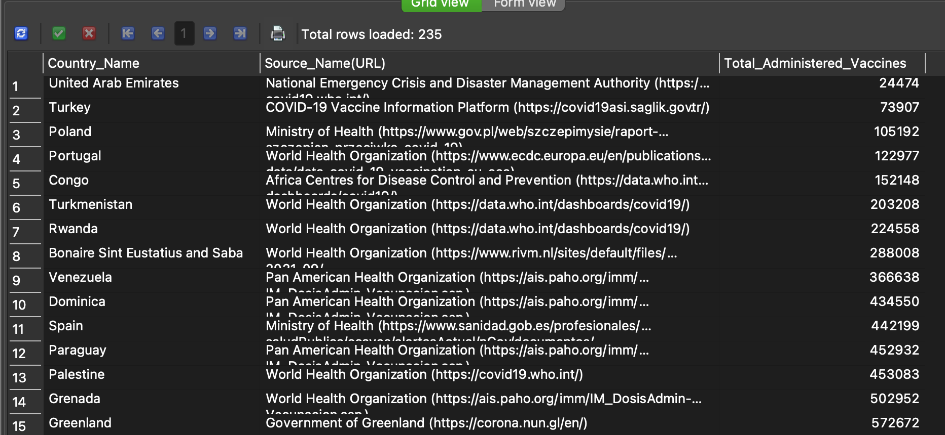

The chart on the left shows the frequency of each source name (URL) used. The World Health Organization entries are labeled as URL1, URL2, and URL3 because the original data had the same source name associated with different URLs, resulting in different URL combinations for the same source name.

The chart on the right shows the locations with the highest total number of administered vaccines. It's surprising to note that Yemen, based on the latest data, has the highest number of administered vaccines, almost equivalent to the entire number in South Africa. Interestingly, most of the top-ranked locations are not highly populated countries. For instance, Samoa, with a population of just over 220,000, raises questions about the accuracy of the original data statistics or the potential impact of specific policies in those areas on the statistical results.

**4.5**

SELECT

c.month AS "Date Range (Months)", -- Formatting month for display

CASE -- this case statement is to turn blank or NULL value to prompt text

WHEN u.people_fully_vaccinated IS NULL OR u.people_fully_vaccinated = '' THEN 'No complete data for the month'

ELSE u.people_fully_vaccinated

END AS "United States",

CASE

WHEN w.people_fully_vaccinated IS NULL OR w.people_fully_vaccinated = '' THEN 'No complete data for the month'

ELSE w.people_fully_vaccinated

END AS "Wales",

CASE

WHEN c.people_fully_vaccinated IS NULL OR c.people_fully_vaccinated = '' THEN 'No complete data for the month'

ELSE c.people_fully_vaccinated

END AS "Canada",

CASE

WHEN d.people_fully_vaccinated IS NULL OR d.people_fully_vaccinated = '' THEN 'No complete data for the month'

ELSE d.people_fully_vaccinated

END AS "Denmark"

FROM

( -- Subquery to get the last day of each month for Canada and its total fully vaccinated count

SELECT

strftime('%Y-%m', date) AS month,

people_fully_vaccinated

FROM

Certain_Country_Records

WHERE

iso_code = 'CAN'

AND strftime('%Y', date) IN ('2022', '2023')

AND date IN (

SELECT

MAX(date) -- use the last day of the month to count the total fully vaccinated number, becuase people_fully_vaccinated is a cumulative value.

FROM

Certain_Country_Records

WHERE

iso_code = 'CAN'

AND strftime('%Y', date) IN ('2022', '2023')

GROUP BY

strftime('%Y', date), strftime('%m', date)

)

) AS c

LEFT JOIN

(-- Logic is the same as above, just changing the iso_code to USA

SELECT

strftime('%Y-%m', date) AS month,

people_fully_vaccinated

FROM

Certain_Country_Records

WHERE

iso_code = 'USA'

AND strftime('%Y', date) IN ('2022', '2023')

AND date IN (

SELECT

MAX(date)

FROM

Certain_Country_Records

WHERE

iso_code = 'USA'

AND strftime('%Y', date) IN ('2022', '2023')

GROUP BY

strftime('%Y', date), strftime('%m', date)

)

) AS u

ON c.month = u.month

LEFT JOIN

(-- Logic is the same as above, just changing the iso_code

SELECT

strftime('%Y-%m', date) AS month,

people_fully_vaccinated

FROM

Certain_Country_Records

WHERE

iso_code = 'OWID_WLS'

AND strftime('%Y', date) IN ('2022', '2023')

AND date IN (

SELECT

MAX(date)

FROM

Certain_Country_Records

WHERE

iso_code = 'OWID_WLS'

AND strftime('%Y', date) IN ('2022', '2023')

GROUP BY

strftime('%Y', date), strftime('%m', date)

)

) AS w

ON c.month = w.month

LEFT JOIN

( -- Logic is the same as above, just changing the iso_code

SELECT

strftime('%Y-%m', date) AS month,

people_fully_vaccinated

FROM

Certain_Country_Records

WHERE

iso_code = 'DNK'

AND strftime('%Y', date) IN ('2022', '2023')

AND date IN (

SELECT

MAX(date)

FROM

Certain_Country_Records

WHERE

iso_code = 'DNK'

AND strftime('%Y', date) IN ('2022', '2023')

GROUP BY

strftime('%Y', date), strftime('%m', date)

)

) AS d

ON c.month = d.month

WHERE

-- Filter out rows where all countries have no complete data to display

(c.people_fully_vaccinated IS NOT NULL AND c.people_fully_vaccinated != '') OR

(u.people_fully_vaccinated IS NOT NULL AND u.people_fully_vaccinated != '') OR

(w.people_fully_vaccinated IS NOT NULL AND w.people_fully_vaccinated != '') OR

(d.people_fully_vaccinated IS NOT NULL AND d.people_fully_vaccinated != '')

ORDER BY

c.month;

The chart shows a comparison of the growth rates for these four countries during the observation period. Due to the significant differences in population between each country, comparing growth rates provides more meaningful information than the raw vaccine administration numbers originally obtained from the table. The line chart presents data until there are no valid data points for each country. It can be observed that the USA's growth rate declined the slowest during this period, while Denmark and Canada only showed a significant increase in early 2022, maintaining a stable growth rate otherwise. Wales experienced a peak from May 2022 to September 2022.